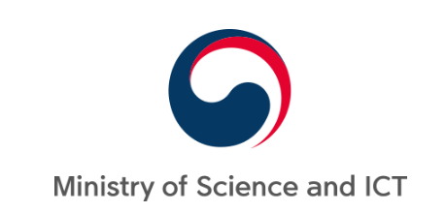 | 

OECD-Korea workshop sTRENGTHENING lINKAGES BETWEEN sTI AND ODA POLICIES IN ORDER TO ADDRESS THE GRAND CHALLENGES AND PROMOTE INCLUSIVE GROWTH 20-21 September, 2018 Venue: JW Marriott Hotel, Seoul, Korea

Registration form

- Personal Information
1 | Title (Ms., Mr., Prof., Dr.)
2 | Last name
3 | First name
4 | Organisation / Company  full name
5 | Position
6 | Address
7 | Post Code / City
8 | Country
9 | Work phone number
10 | Mobile phone number
11 | E-mail address

- Visa support

I require an official invitation to the Republic of Korea for visa support  (If yes, please return the completed Application form for visa invitation and a scanned copy of your passport (first two pages with photo) at your earliest convenience.  Please note that your passport should be valid for at least 6 months after the end of the Korean visa period). | yes | no

Please return the completed form to Ms. Yong-in Choi (e-mail: luciachoi@stepi.re.kr;
tel.: +82 44 287 2225).

